Step 1: Open the lab link to access the Kali machine.
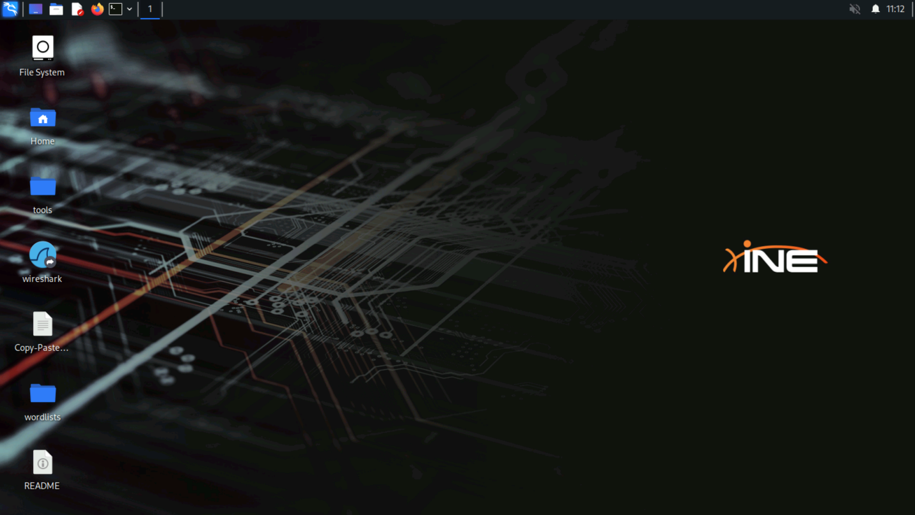
Step 2: Check if the target machine is reachable:
Command:
ping -c 4 demo.ine.local
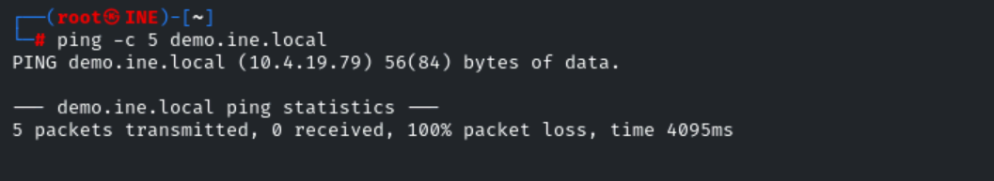
The target machine is not reachable. Let's use Nmap to skip the host discovery phase and assume that the hosts are online. This is useful in environments where ICMP echo requests (ping) are blocked by firewalls, which would normally prevent Nmap from detecting if a host is up.
Step 3: Importing Nmap scan results into MSF
Perform the Nmap scan and save the output in XML format.
Command:
nmap -sV -Pn demo.ine.local -oX result.xml
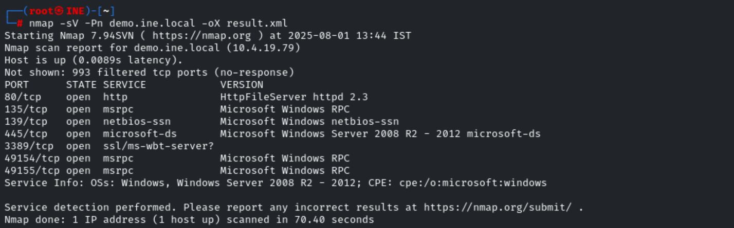

After performing an Nmap scan and exporting a scan results XML format, you can import the results directly into the MSF.
To begin with, you will need to start the postgresql database service. This can be done by running the following command:
Command:
service postgresql start
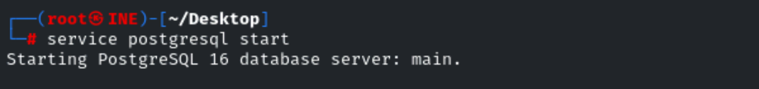
We can now start the Metasploit Framework console (msfconsole) by running the following command:
Command:
msfconsole
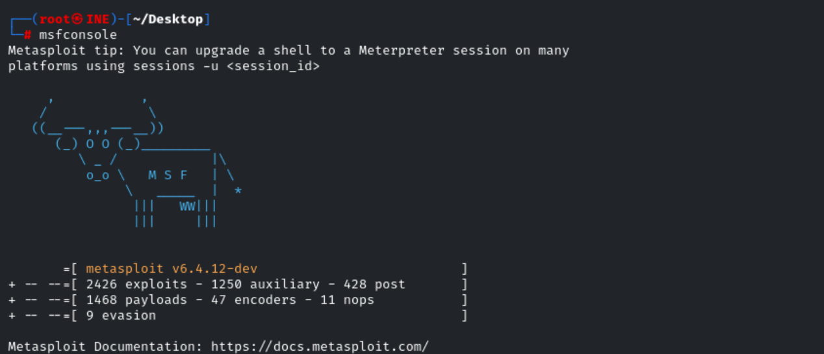
Once the Metasploit Framework console (msfconsole) is started, you can verify that the MSF database is connected by running the following command:
Command:
db_status
As shown in the following screenshot, MSF is connected to the database.

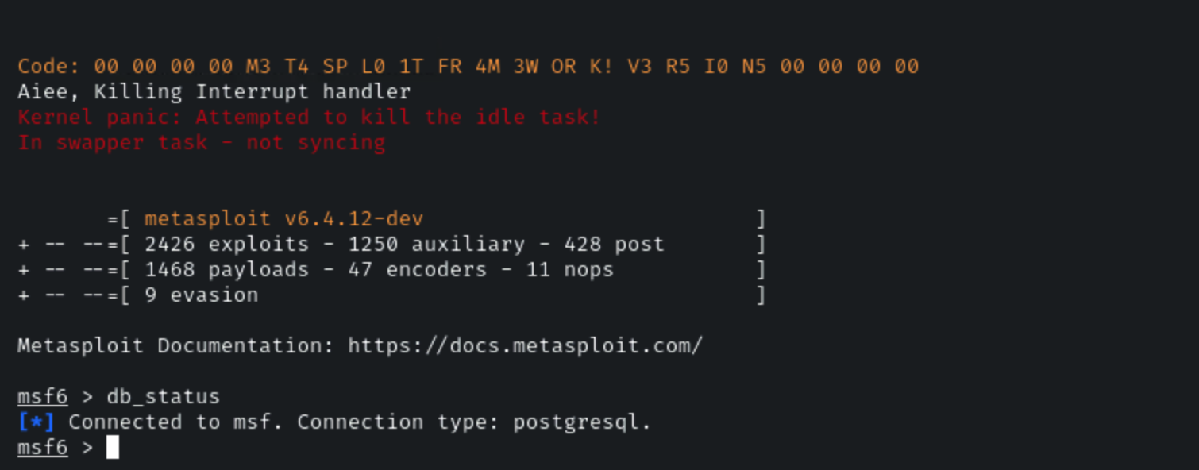
You can now import the Nmap scan results, in this case, we will be importing the scan results from the previous lab exercise.
This can be done by running the following command:
Command:
db_import myscan.xml
As shown in the following screenshot, the results are successfully imported.
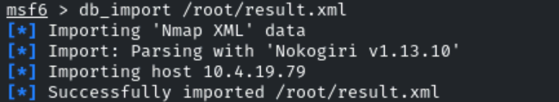
We can now view the results by running the following commands:
Command:
hosts
services
As shown in the following screenshot, the Nmap scan results have been successfully imported into MSF.
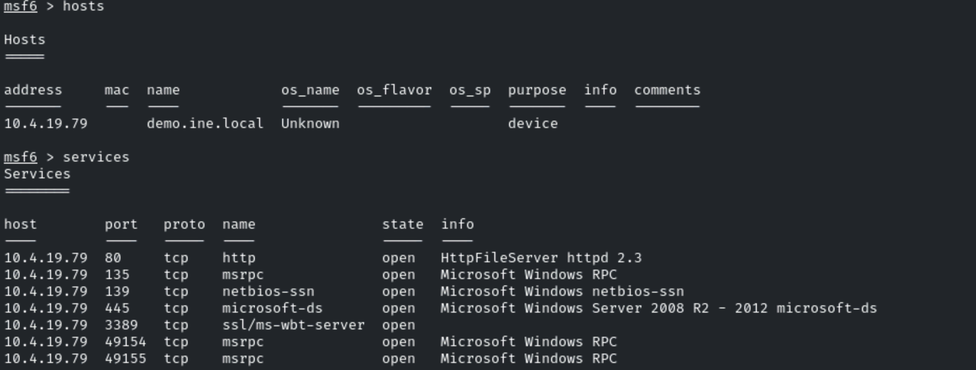
Conclusion
This lab demonstrates the process of importing Nmap scan results into the Metasploit Framework, enabling efficient integration of network discovery and vulnerability exploitation.

